**Ethereal – MYTH**

**MYTH description**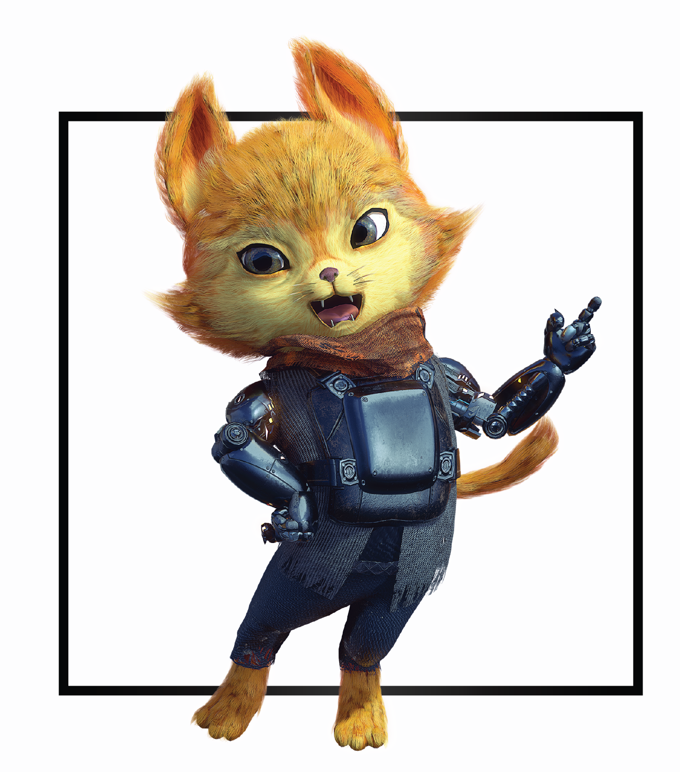

|  |  |
| --- | --- |
| **Name** | Nicholai |
| **Title** | Instrument of Hope |
| **Realm** | Ovagon |
| **Region** | District 1 |
| **Class** | Cleric |
| **Type** | Ranged Magical |
| **Release Date** | Coming Soon |

Nicholai took a deep breath, his tail wagging behind him with nerves. Soft opera music filled the air in honor of the doctor’s arrest. Nicholai remembered his part of the plan down to the exact words he would say when the soldiers caught him. He rushed to finish it, aware of the consequences if any unintended research fell into military control.

Steeling himself, Nicholai drew his full attention to the room in front of him. His ears twitched. Footsteps, once faint, grew louder by the second as he tightened the red bandana around his neck. Nicholai inhaled, grasped battered drumsticks in one tense paw and tapped into his powers. Ready, when the doors swing open.  *Don't flinch!*

Armed capitol agents rushed towards him, the first began to shoot. *Bang! Bang! Bang!* A second, then third joined in, their bullets pinging harmlessly off Nicholai’s unmoving body. The agents moved steadily closer. Once they were exactly three feet away, Nicholai straightened to slam Dr. Lent’s drumsticks on the ground. Shockwaves of beats surged outward, all agents flung through the air as musical waves bounced off the walls.

In the mayhem, Nicholai turned and jumped onto a nearby console. Without hesitation he pressed the memorized button sequence, ignoring the grunts rushing towards him. Lights around the room glowed red with urgent warnings as the music abruptly halted. The first agent made another grab for him, Nicholai dodged and bashed the agent's face against the panel beneath him. He leapt to the next agent knocking her down and rushed the remaining agent. Nicholai slipped between his legs and with another musical outburst everyone soared outwards as he rushed to the primary data compartment.

His cybernetic arms sparked as they connected to the central port. All agents, back on their feet, searched around the room. A few more seconds... Nicholai finished the file upload! Loud heavy bass boomed from the speakers, specific research and inventions either encrypted or self-destructed as the kill switch spread through the facility.

A serene smile stretched across his face as he sat and waited for hands to press him to the floor. *Nicholai did it!* He completed his part of the plan.